Digital Spelling Dictionary

What is Digital Spelling Dictionary
# Source: AI Source: Provided by: [Data Path: Persons Table -> ID Column: 1, Name_En Column: Motasem Essam] -> From: [Chatgpt (GPT-4-turbo)] on [7/30/2025]
A Digital Spelling Dictionary is an electronic tool or software designed to provide instant spelling assistance through digital platforms such as computers, smartphones, tablets, or online services. It often combines traditional dictionary features with smart technologies like spell-check, autocorrect, audio support, and predictive text.

✅ Key Features:
# Source: AI Source: Provided by: [Data Path: Persons Table -> ID Column: 1, Name_En Column: Motasem Essam] -> From: [Chatgpt (GPT-4-turbo)] on [7/30/2025]
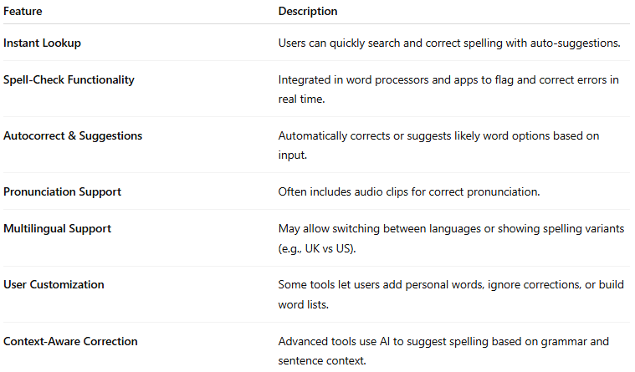
Feature | Description
Instant Lookup | Users can quickly search and correct spelling with auto-suggestions.
Spell-Check Functionality | Integrated in word processors and apps to flag and correct errors in real time.
Autocorrect & Suggestions | Automatically corrects or suggests likely word options based on input.
Pronunciation Support | Often includes audio clips for correct pronunciation.
Multilingual Support | May allow switching between languages or showing spelling variants (e.g., UK vs US).
User Customization | Some tools let users add personal words, ignore corrections, or build word lists.
Context-Aware Correction | Advanced tools use AI to suggest spelling based on grammar and sentence context.

👤 Target Audience:
# Source: AI Source: Provided by: [Data Path: Persons Table -> ID Column: 1, Name_En Column: Motasem Essam] -> From: [Chatgpt (GPT-4-turbo)] on [7/30/2025]
- General users (writers, students, teachers)
- Professionals (editors, translators, researchers)
- ESL/EFL learners
- People with dyslexia or writing difficulties

💻 Examples of Digital Spelling Dictionaries/Tools:
# Source: AI Source: Provided by: [Data Path: Persons Table -> ID Column: 1, Name_En Column: Motasem Essam] -> From: [Chatgpt (GPT-4-turbo)] on [7/30/2025]
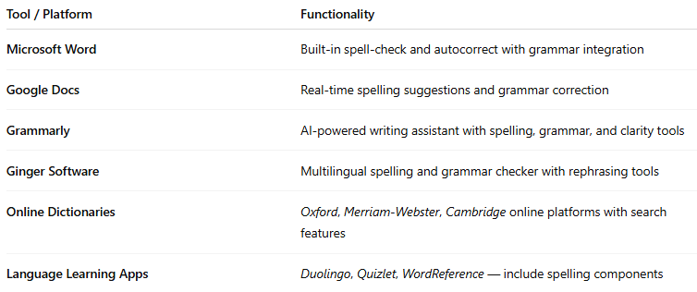
Tool / Platform | Functionality
Microsoft Word | Built-in spell-check and autocorrect with grammar integration
Google Docs | Real-time spelling suggestions and grammar correction
Grammarly | AI-powered writing assistant with spelling, grammar, and clarity tools
Ginger Software | Multilingual spelling and grammar checker with rephrasing tools
Online Dictionaries | Oxford, Merriam-Webster, Cambridge online platforms with search features
Language Learning Apps | Duolingo, Quizlet, WordReference — include spelling components

🟢 Benefits:
# Source: AI Source: Provided by: [Data Path: Persons Table -> ID Column: 1, Name_En Column: Motasem Essam] -> From: [Chatgpt (GPT-4-turbo)] on [7/30/2025]
- Fast and efficient spelling correction
- Helps non-native speakers and users with writing difficulties
- Often combined with grammar and style tools
- Portable and always accessible across devices

🔴 Limitations:
# Source: AI Source: Provided by: [Data Path: Persons Table -> ID Column: 1, Name_En Column: Motasem Essam] -> From: [Chatgpt (GPT-4-turbo)] on [7/30/2025]
- May encourage over-reliance
- Not always contextually accurate (e.g., their vs there)
- Requires internet access or software updates for full functionality

